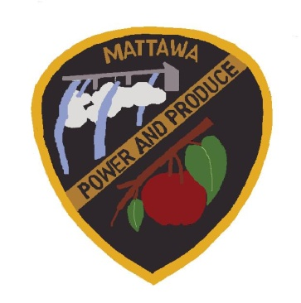
CITY OF MATTAWA
COUNCIL MEETING AGENDA
MAY 06, 2021
5:30 P.M.

Due to the emergency proclamation of Covid-19 epidemic, we will be holding this meeting remotely via Zoom.

----------------------------------------------------------------------------------------------------------
Call to Order:
Roll Call: Mayor Maria Celaya, Sun Hwang, Brian Berghout, Silvia Barajas, Tony Acosta, Alex Heredia, Vicente Acosta, Wendy Lopez.

Additions/Approval of Agenda
Reports:
Mayor/Council Report

Police Department Report
- COPs Grant Update – Wahluke School District DJ Garza

Public Works Department Report
- Recycling Program Update

Darryl Piercy, City Planner Report

Council, Items for Motion (Old Business):

- Subcommittees Guidelines
- Mattawa Municipal Code Chapter 6.10 Chickens

Council, Items for Motion (New Business):

- Event Permit – WHS Senior Class Parade
- Current Administrative Assistant Job Description for Council to Approve for Job Posting - MPD
- Revision of Employee Policy Handbook Chapter 8.15
- WGL Project Letter of Support

- Authorization to Sign Contract for Construction of the Government Rd. Sidewalk Project
- Review 6-Year Transportation Improvement Plan 2022-2027
- License Agreement for Library Wi-Fi
- T-Mobile Agreement
- Firefly Quote – Server
- Request for Section 7 Emergency Hire – MPD
- Addendum to Staffing Report – MPD
- Liquor License Renewal; Fabela’s Market

Consent Agenda:

Minutes- April 15, 2021, Special Council Meeting Minutes April 20 & 27, 2021
2021 Claims EFT & Checks Approval #18525-18550- $100,409.84
2021 Payroll EFT & Checks Approval #31670-31680-$113,766.46

Public Comments:

Adjourn:

