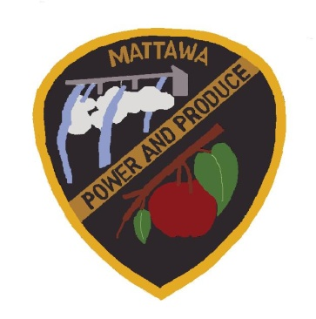
CITY OF MATTAWA
COUNCIL MEETING AGENDA
JULY 07, 2022
5:30 P.M.

Call to Order:
Roll Call: Mayor Maria Celaya, Sun Hwang, Brian Berghout, Silvia Barajas, Tony Acosta, Alex Heredia, Fabiola Hernandez, Wendy Lopez

Additions/Approval of Agenda

Reports:

Mayor Report

Council Report

Clerk’s Department Report

Police Department Report

Public Works Department Report

Council, Items for Motion (Old Business):

- Annexation Moratorium

Council, Items for Motion (New Business):

- Event Permit Application – Benancio Garcia Rally
- Res. 22.07.07 National Night Out (Law Enforcement)
- Res. 22.07.08 Surplus
- Res. 22.07.09 Policy Review
- Amending Job Description – Customer Service Clerk
- MACC Agreement
- MACC Public Safety Software

- Amending Fee Schedule
- 2022 Festival & Events Grant
- Ord. 22-676 Budget Amendment #4
- TIB Cost Estimate Approval for 8th St. & Selkirk
- Award to Double J Excavating, Inc. – 8th St. & Selkirk Ave. Project
- Selection of Engineering Firm 2022-2023

Consent Agenda/Informational:

- Minutes- Council Meeting 06.16.22
- Gray & Osborne Project 6.17.22
- 2022 Claims EFT & Checks Approval #19277-19300 - $53,650.67
- 2022 Payroll EFT & Checks Approval #31779-31786- $125,623.53
- April ’22 Treasurer Report

Public Comments:

Adjourn:

