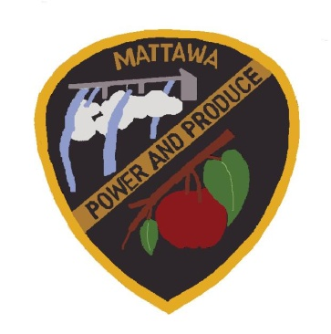
CITY OF MATTAWA
COUNCIL MEETING AGENDA
JUNE 03, 2021
5:30 P.M.

Due to the emergency proclamation of Covid-19 epidemic, we will be holding this meeting remotely via Zoom.

----------------------------------------------------------------------------------------------------------
Call to Order:
Roll Call: Mayor Maria Celaya, Sun Hwang, Brian Berghout, Silvia Barajas, Tony Acosta, Alex Heredia, Vicente Acosta, Wendy Lopez.

Additions/Approval of Agenda

Reports:
Mayor/Council Report

Police Department Report

Public Works Department Report

Darryl Piercy, City Planner Report

Council, Items for Motion (New Business):

- HAPO Presentation
- BVP Grant Application - MPD
- Surplus Firearms – MPD
- Sale of Surplus Radios – MPD
- Police Chief Job Description – Amended – Review & Discussion
- Recruitment Services for Police Chief – Prothman
- Vacation Bible School Event Application
- Approval of Progress Estimate #1 – Government Road Sidewalk Improvements – Wheeler Excavation, LLC.
- Ordinance 21-658 Budget Amendment 2021 #6

Consent Agenda:

Minutes- May 20, 2021
2021 Claims EFT & Checks Approval #18586-18606- $109,947.13
2021 Payroll EFT & Checks Approval #31681-31687 -$99,443.95

Public Comments:

Adjourn:

