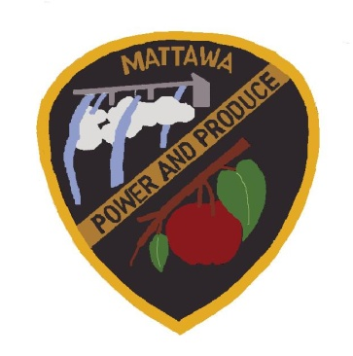
CITY OF MATTAWA
SPECIAL COUNCIL MEETING AGENDA
January 11, 2021
5:30 P.M.

Due to the emergency proclamation of Covid-19 epidemic, we will be holding this meeting remotely.

----------------------------------------------------------------------------------------------------------
Call to Order:
Roll Call: Mayor Maria Celaya, Sun Hwang, Brian Berghout, Silvia Barajas, Tony Acosta, Alex Heredia and Wendy Lopez.

Old Business:

New Business:

Reports:
Mayor/Council Report

Police Department Report
- Calls for Service December 2020

Public Works Department Report

Darryl Piercy, City Planner Report

Council, Items for Motion:

- WSD – COPS Grant
- WSD – SRO Contract
- WWTF – Easement and Right-A-Way Agreement
- Resolution 20.01.01 Grant/Award Policy & Grant Application Policy No. 2021-1
- Resolution 20.01.02 Budget Policy & Fund Balance Policy No. 2021-2

- Cares Act

Consent Agenda:

Minutes- Dec. 17, 2020, Special Council Meeting Dec. 29, 2020 & Jan. 7, 2021
2020 Claims EFT & Checks Approval #18282-18308-- $48,130.17
2020 Payroll EFT & Checks Approval #31643-#31648 --$107,725.56
2021 Claims EFT & Checks Approval #18309-18315-- $101,578.75

Public Comments:

Executive Session: RCW 42.30.110
(g) To evaluate the qualifications of an applicant for public employment or to review the performance of a public employee
(1)(b) To consider purchase of real estate

Adjourn:

