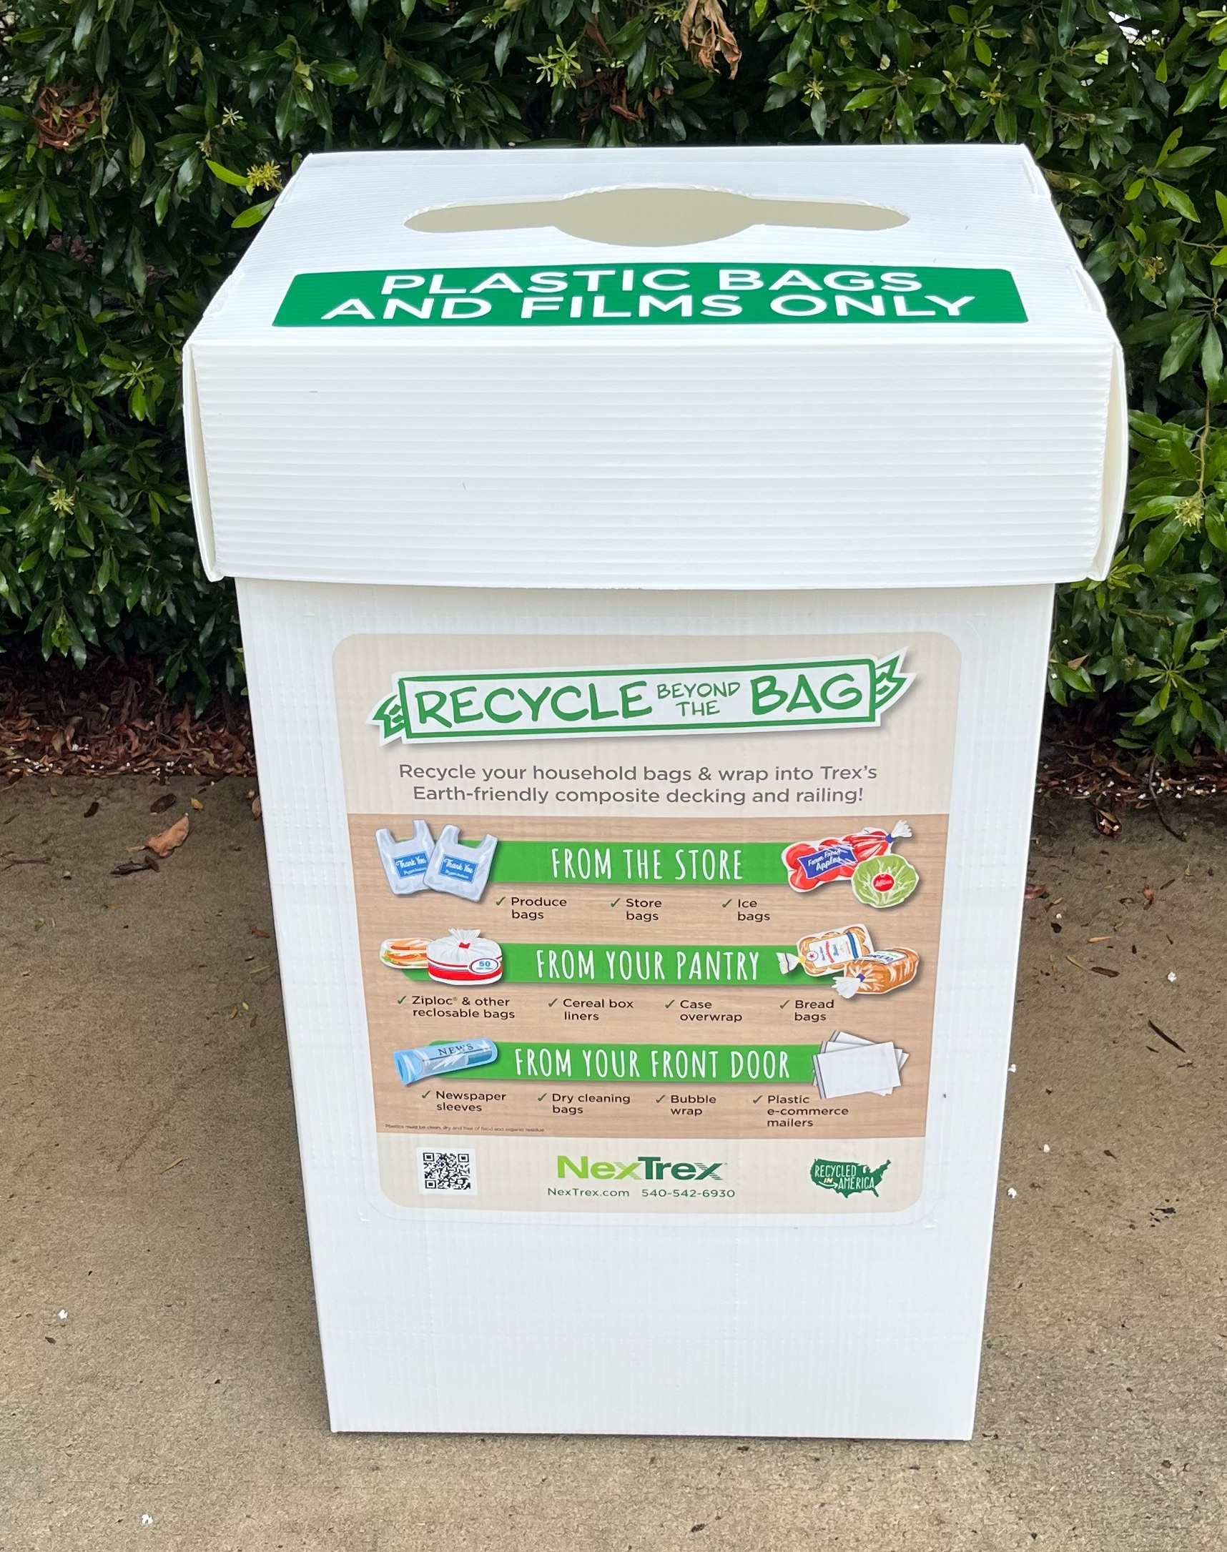
The St. James Recycling Committee is excited to announce that we have joined the NexTrex Plastic Challenge. Our goal is to collect 1000 pounds of polyethylene plastic by March 2026. If it stretches, then it is most likely acceptable. Please visit our sidewalk drop-off collection site near the Town Hall gazebo, starting Monday, June 16th, between 9-11 AM. Starting in July collections will be made on the 1st and 3rd Monday of each month (9-11 AM). Just bag your stretchy plastic, stop by the curb and deposit the bag in our designated bin. We will be there to assist all drivers if needed. Contact Gerry Rosenthal with any questions - geraldivan988@gmail.com

Thank you for caring about our local environment.

